Library Management System
SR | USER Requirements | GPT Result | Our Result
 | The Member clicks the log-in button on the Home Page. | 1 The system shall provide users with the ability to click the log-in button on the Home Page. | 1. The system shall provide member with the ability to click the login button on the home page.
 | The system displays the log-in page. | 2 The system shall be able to display the log-in page when the log-in button is clicked. | 2. The system shall be able to display the login page.
 | The member enters his login Id with password. | 3 The system shall provide users with the ability to enter a login ID and password on the log-in page. | 3. The system shall provide member with the ability to enter his login i d with password.
 | The member clicks on the confirm button. | 4 The system shall provide users with the ability to click the confirm button after entering login credentials. | 4. The system shall provide member with the ability to click on the confirm button.
 | The system checks that all of the required information was entered. | 5 The system shall be able to check that all required login information has been entered. | 5. The system shall be able to check that all of the required information entered.
 | If the entered information is wrong then system asks member to reenter the details. | 6 If required login information is missing, then the system shall be able to prompt the user to enter all required fields. | 6. If the entered information is wrong then the system shall be able to ask member to reenter details.
 | The system validates the entered information against the tables stored in the database. | 7 The system shall be able to validate the entered login credentials against the database. | 7. The system shall be able to validate the entered information against the tables stored in the database.
 | Member must be logged in to the system. | Missing | 8. The system shall provide member with the ability to logged in.
 | The member clicks on View user details. | 12 The system shall provide logged-in members with the ability to click on "View user details." | 9. The system shall provide member with the ability to click on view user details.
 | The system opens a page showing the details of the member. | 13 The system shall be able to display a page showing the member’s details when "View user details" is selected. | 10. The system shall be able to open a page showing the details of the member.
 | The details include the total number of issued books, date of issue, return date, fine to be paid. | 14 The system shall be able to display the total number of books issued to the member. | 11. The system shall provide details with the ability to include the total number of issued books , date of issue , return date , fine to paid.
 | The member closes the page. | 18 The system shall provide members with the ability to close the user details page. | 12. The system shall provide member with the ability to close the page.
 | The system shows OK message. | 19 The system shall be able to display an "OK" message when the user details page is closed. | 13. The system shall be able to show ok message.
 | The books should be stored in database. | 20 The system shall be able to store book records in the database. | 14. The system shall be able to stored books database.
 | The books must be ready to retrieve. | 21 The system shall be able to retrieve book records from the database. | 15. The system shall be able to retrieve ready books.
 | The system asks user to login. | Missing | 16. The system shall be able to ask user to login.
 | The system identifies the type of user- member, guest or administrator. | 10 The system shall be able to identify the type of user upon login (member, guest, or administrator). | 17. The system shall be able to identify the type of user member , guest or administrator.
 | The system shows the categories to browse. | 22 The system shall be able to display categories of books to browse. | 18. The system shall be able to show the categories to browse.
 | The user selects a category of books to view. | 23 The system shall provide users with the ability to select a category of books to view. | 19. The system shall provide user with the ability to select a category of books to view.
 | If no category is selected by the user then the system again asks user to select a category. | 24 If no category is selected by the user, then the system shall be able to prompt the user to select a category. | 20. If no category is selected by the user then the system shall be able to select again asks user to select a category.
 | The system checks the books in the database. | 25 The system shall be able to check for books in the database corresponding to the selected category. | 21. The system shall be able to check the books in the database.
 | The system retrieves all the books falling in that category. | 26 The system shall be able to retrieve all books in the selected category from the database. | 22. The system shall be able to retrieve all the books falling in that category.
 | The user selects the desired books. | 27 The system shall provide users with the ability to select one or more books from the displayed list. | 23. The system shall provide user with the ability to select the desired books.
 | The system shows the details of the selected books. | 28 The system shall be able to display the details of the selected books. | 24. The system shall be able to show the details of the selected books.
 | The system asks user to print the details. | 29 The system shall be able to prompt the user to print the details of the selected books. | 25. The system shall be able to ask user to print the details.
 | If User does not want to print the details then user can ignore the step. | 30 The system shall provide users with the ability to ignore the print prompt if they do not wish to print. | 26. If user does not want to print the details then the system shall be able to ignore user step.
 | User can reserve a book by inputting the relevant details. | 31 The system shall provide users with the ability to reserve a book by inputting relevant details. | 27. The system shall provide user with the ability to reserve a book by inputting the relevant details.
 | The librarian can also reserve a book for a member. | 32 The system shall provide librarians with the ability to reserve a book for a member. | 28. The system shall provide librarian with the ability to also reserve a book for a member.
 | User should be logged into the system. | 33 If a user attempts to reserve a book, then the system shall verify that the user is logged in. | 29. The system shall provide user with the ability to logged in.
 | User should have correct book Id. | 34 If a user attempts to reserve a book, then the system shall verify that a correct Book ID has been provided. | 30. The system shall provide user with the ability to have correct book i d.
 | Books should be available to reserve. | 35 If a user attempts to reserve a book, then the system shall verify that the book is available for reservation. | 31. Books available to reserve.
 | The system identifies the type of user- member, guest or administrator. | 10 The system shall be able to identify the type of user upon login (member, guest, or administrator). | 33. The system shall be able to identify the type of user member , guest or administrator.
 | The system shows the categories to browse. | 46 The system shall be able to display categories of books to browse for searching. | 34. The system shall be able to show the categories to browse.
 | The user selects book to reserve. | Missing | 35. The system shall provide user with the ability to select book to reserve.
 | If no book is selected by the user then the system again asks user to select a book to reserve. | 40 If no book is selected by the user for reservation, then the system shall prompt the user to select a book. | 36. If no book is selected by the user then the system shall be able to select again asks user to select a book to reserve.
 | The user enters Book Id to reserve. | 41 The system shall provide users with the ability to enter a Book ID to reserve. | 37. The system shall provide user with the ability to enter book i d to reserve.
 | If the book Id is wrong then system asks user to recheck the book id. | 42 If the entered Book ID is invalid, then the system shall prompt the user to recheck and re-enter the Book ID. | 38. If the book id is wrong then the system shall be able to be asks user to recheck bookThe system shall be able to d.
 | The system checks the books in the database. | 43 The system shall be able to check the reservation status of the book in the database. | 39. Books database.
 | If the selected book is already reserved on another Id then system asks user to select another book. | 44 If the selected book is already reserved under another ID, then the system shall prompt the user to select another book. | 40. If the selected book is already reserved on another id then the system shall be able to asks user to select another book.
 | Members should be logged into the system. | Missing | 41. The system shall be able to logged members.
 | Guest user can also search books. | 45 The system shall allow guest users to search for books. | 42. The system shall be able to search books.
 | Book should be available to search. | Missing | 43. The system shall provide book with the ability to available to search.
 | The system shows the categories to browse. | 46 The system shall be able to display categories of books to browse for searching. | 44. The system shall be able to show the categories to browse.
 | The member selects a category of searching a book. | 47 The system shall provide members with the ability to select a category for searching books. | 45. The system shall provide member with the ability to select a category of searching a book.
 | If no category is selected by the member then the system again asks user to select a category. | 48 If no category is selected by the member during search, then the system shall prompt the member to select a category. | 46. If no category is selected by the member then the system shall be able to ask again user to select a category.
 | The system checks the books in the database. | 49 The system shall be able to check for books in the database corresponding to the selected search category. | 47. The system shall be able to check the books in the database.
 | The system retrieves all the books falling in that category. | 50 The system shall be able to retrieve all books in the selected search category from the database. | 48. The system shall be able to retrieve all the books falling in that category.
 | Books should be available to issue. | 51 The system shall require members to provide their member ID to the librarian for book issuing. | 50. The system shall be able to available books issue.
 | The librarian Checks the availability of the books. | 52 The system shall be able to check the availability of books for issuing. | 51. The system shall provide librarian with the ability to check the availability of the books.
 | The librarian also checks total number of books issued on that Id. | 53 The system shall be able to check the total number of books issued to a member ID. | 52. The librarian also checks total number of books issued on that id.
 | The librarian cannot issue the books if the user has three books issued on his Id. | 54 The system shall prevent the librarian from issuing books if the member already has three books issued. | 54. The system shall provide user with the ability to not issue the books if the has three books issued on his i d.
 | Librarian issues the book. | 55. The system shall provide librarians with the ability to issue a book to a member. | - Librarian issues the book.
 | The system updates the information in database. | 56 The system shall be able to update the database when a book is issued. | 55. The system shall be able to update the information in database.
 | Librarian should be logged into the system. | 57 The system shall require librarians to be logged in to issue books. | 56. The system shall be able to loggedThe system shall provide member with the ability to borrow books.
 | Member should have borrowed books. | 58 The system shall require members to have borrowed books before returning them. | Missing
 | Member should give the member Id to the librarian. | 59 The system shall require members to provide their member ID to the librarian for book return. | 57. The system shall provide member with the ability to give the member i d to the librarian.
 | The member returns the book. | 60 The system shall provide members with the ability to return a book. | 58. The system shall provide member with the ability to return the book.
 | The librarian enters book id , member id in the system. | 61 The system shall provide librarians with the ability to enter the Book ID and Member ID for book return. | 59. The system shall provide librarian with the ability to enter book i d , member i d in the system.
 | If the entered book id is incorrect then system asks to re-enter the book id. | 62 If the entered Book ID is incorrect during return, then the system shall prompt the librarian to re-enter the Book ID. | 60. If the entered book id is incorrect then the system shall be able to ask to reenter book i d.
 | The system prompts a message that the book with book id is successfully returned. | 63 The system shall be able to prompt a message confirming successful return of the book with the specified Book ID. | 61. Prompts a message that book with book i d successfully returned.
 | Members should be stored in the database. | 64 The system shall be able to store member records in the database. | 62. The system shall be able to stored members database.
 | Members should be available to retrieve by the system. | 65. The system shall be able to retrieve member records from the database. | 63. The system shall be able to retrieve available members.
 | Member must be logged in to the system. | Missing | 64. The system shall provide member with the ability to logged in.
 | Guest can also view members. | 66 The system shall allow guests to view member details. | 65. The system shall provide guest with the ability to also view members.
 | The user clicks on View members. | 67 The system shall provide users with the ability to click on "View members." | 66. The system shall provide user with the ability to click on view members.
 | The system opens a page showing the details of the member. | 68 The system shall be able to display a page showing member details, including name, total number of issued books, date of issue, return date, and fine to be paid. | 67. The system shall be able to open a page showing the details of the member.
 | The details include name of member, the total number of issued books, date of issue, return date, fine to be paid. | Missing | 68. The system shall provide details with the ability to include name of member , the total number of issued books , date of issue , return date , fine to paid.
 | The member closes the page. | 69 The system shall provide members with the ability to close the member details page. | 69. The system shall provide member with the ability to close the page.
 | Librarian should be logged into the system. | 70 The system shall require librarians to be logged in to add or remove books. | 70. The system shall be able to loggedThe system shall be able to remove available books.
 | Books should be available to remove. | 71 The system shall verify that books are available before allowing removal. | Missing
 | Book details should be available to add or remove books in the database. | 72 The system shall verify that book details are available before allowing addition or removal in the database. | 71. The system shall provide details with the ability to available to add or remove books in the database.
 | The librarian has option of adding or removing a book in database. | 73 The system shall provide librarians with the ability to add a book to the database. | 72. The system shall provide librarian with the ability to have option of adding or removing a book in database.
 | The system asks librarian to add or remove the book. | 75 The system shall prompt the librarian to choose whether to add or remove a book. | 73. The system shall be able to ask librarian to add or remove the book.
 | The system asks librarian to enter all the required details about the new book to be added. | 76 If the librarian selects to add a book, then the system shall prompt the librarian to enter all required details about the new book. | 75. The system shall be able to ask librarian to enter all the required details about the new book to added.
 | The librarian adds a book. | 77 The system shall provide librarians with the ability to enter all required details about the new book to be added. | - The system shall provide librarian with the ability to add a book.
 | The librarian enters the details. | Missing | 76. The system shall provide librarian with the ability to enter the details.
 | If the librarian selects to remove a book then the book should be outdated. | 78 If the librarian selects to remove a book, then the system shall verify that the book is outdated before removal. | 77. If the librarian selects to remove a book then the system shall be able to outdate book be.
 | The system administrator that all the information has been correctly provided. | Missing | 78. The system administrator that all the information has been correctly provided.
 | Administrator should be logged into the system. | 79 The system shall require administrators to be logged in to add or remove members. | 79. The system shall provide administrator with the ability to logged in.
 | Member should be available to remove. | Missing | 80. The system shall provide member with the ability to available to remove.
 | Member details should be available to add or remove member in the database. | 80 The system shall verify that member details are available before allowing addition or removal in the database. | 81. The system shall provide details with the ability to available to add or remove member in the database.
 | The system asks administrator to add or remove a member. | 81 The system shall provide administrators with the ability to add a member to the database. | 82. The system shall be able to ask administrator to add or remove a member.
 | The administrator selects to add a member. | 83 The system shall prompt the administrator to choose whether to add or remove a member. | 83. The system shall provide administrator with the ability to select to add a member.
 | The system asks administrator to enter all the required details about the new member to be added. | 84 If the administrator selects to add a member, then the system shall prompt the administrator to enter all required details about the new member. | 84. The system shall be able to ask administrator to enter all the required details about the new member to added.
 | The administrator enters the details. | 85 The system shall provide administrators with the ability to enter all required details about the new member to be added. | 85. The system shall provide administrator with the ability to enter the details.
 | If the administrator selects to remove a member then a valid reason of removal is required. | 86 If the administrator selects to remove a member, then the system shall require a valid reason for removal. | 86. If the administrator selects to remove a member then the system shall be able to require a valid reason of removal.
 | The system validates that all the information has been correctly provided. | 87 The system shall validate that all required information has been correctly provided when adding or removing a member. | 87. The system shall be able to validate that all the information correctly provided.
 |  | 8. If the entered login credentials are incorrect, then the system shall be able to prompt the user to re-enter the details.
 |  | 9. If the entered login credentials are correct, then the system shall be able to log the user into the system.
 |  | 11. The system shall be able to prompt users to log in when accessing features that require authentication.
 |  | 15 The system shall be able to display the date of issue for each issued book.
 |  | 16 The system shall be able to display the return date for each issued book.
 |  | 17 The system shall be able to display the fine to be paid by the member, if any.
 |  | 36. The system shall prompt users to log in before allowing book reservation.
 |  | 37. The system shall be able to identify the type of user when reserving a book.
 |  | 38. The system shall be able to display categories of books to browse for reservation.
 |  | 39. The system shall provide users with the ability to select a book to reserve.
 |  | 74 The system shall provide librarians with the ability to remove a book from the database.
82 The system shall provide administrators with the ability to remove a member from the database.
88. The system shall validate that all required information has been correctly provided when adding or removing a book.
 |  | 89. The system shall provide appropriate error messages for all invalid or incomplete data entries.
 |  | 90. The system shall provide confirmation messages for all successful operations, including login, book issue, book return, member addition, and book addition.
 |  | 91. The system shall provide feedback to the user on the status of their actions, including errors, confirmations, and prompts for additional information.
 |  | 92. The system shall prevent users from accessing restricted features unless they are logged in with appropriate roles.
 |  | 93. The system shall maintain a session for logged-in users to track their authentication status.
 |  | 94. The system shall log all add, remove, issue, and return transactions for audit purposes.
 |  | 95. The system shall provide a timeout mechanism to log out inactive users after a configurable period.
 |  | 96. The system shall mask password input fields to prevent display of typed characters.
 |  | 97. The system shall enforce password and login ID format validation according to defined security policies.
 |  | 98. The system shall prevent duplicate Book IDs and Member IDs in the database.
 |  | 99. The system shall handle database connection errors gracefully and notify the user of issues.
 |  | 100. The system shall ensure data consistency when updating book and member records in the database.
 |  | 101. The system shall provide a help or support link on all major pages for user assistance.
 |  | 102. The system shall allow users to cancel any operation before final confirmation.
 |  | 103. The system shall provide a logout option for all logged-in users.
 |  | 104. The system shall restrict book addition, removal, and member management features to authorized roles only.
 |  | 105. The system shall log failed login attempts and notify administrators of repeated failures.
 |  | 106. The system shall allow users to reset forgotten passwords via a secure process.
 |  | 107. The system shall display the current logged-in user’s role and name on the main interface.
 |  | 108. The system shall provide a search functionality for books by title, author, or ISBN in addition to category.
 |  | 109. The system shall allow users to sort and filter book search results by various criteria.
 |  | 110. The system shall provide a summary of outstanding fines and dues to members upon login.

Class Diagram (VeriGen)

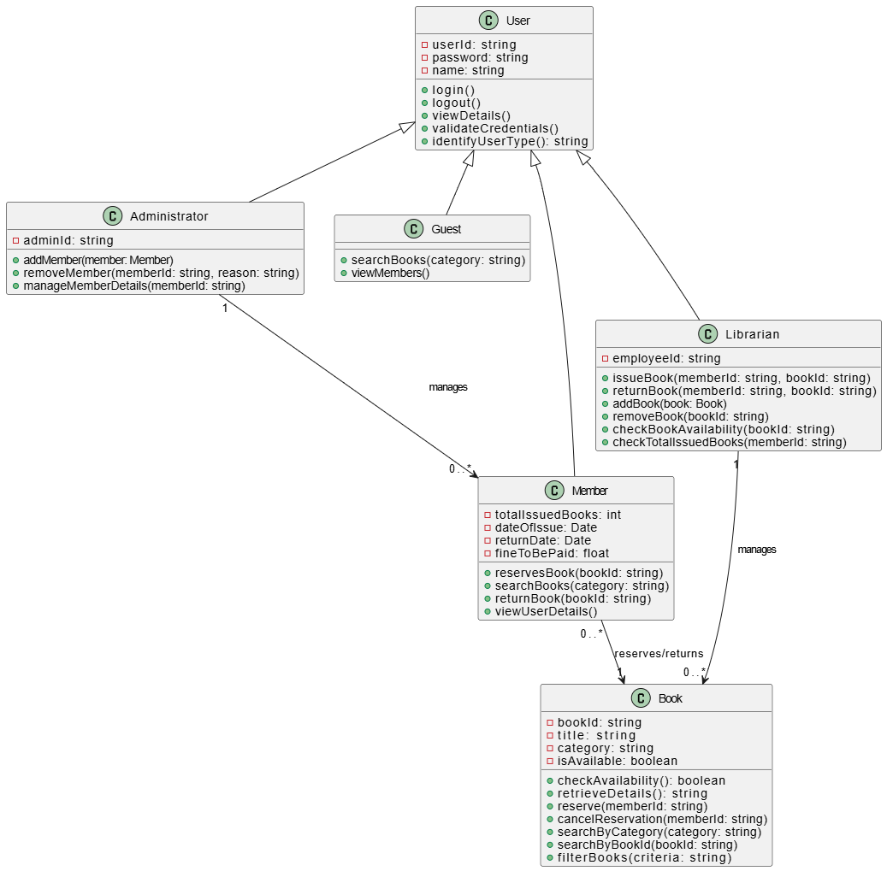

Class Diagram (GPT)

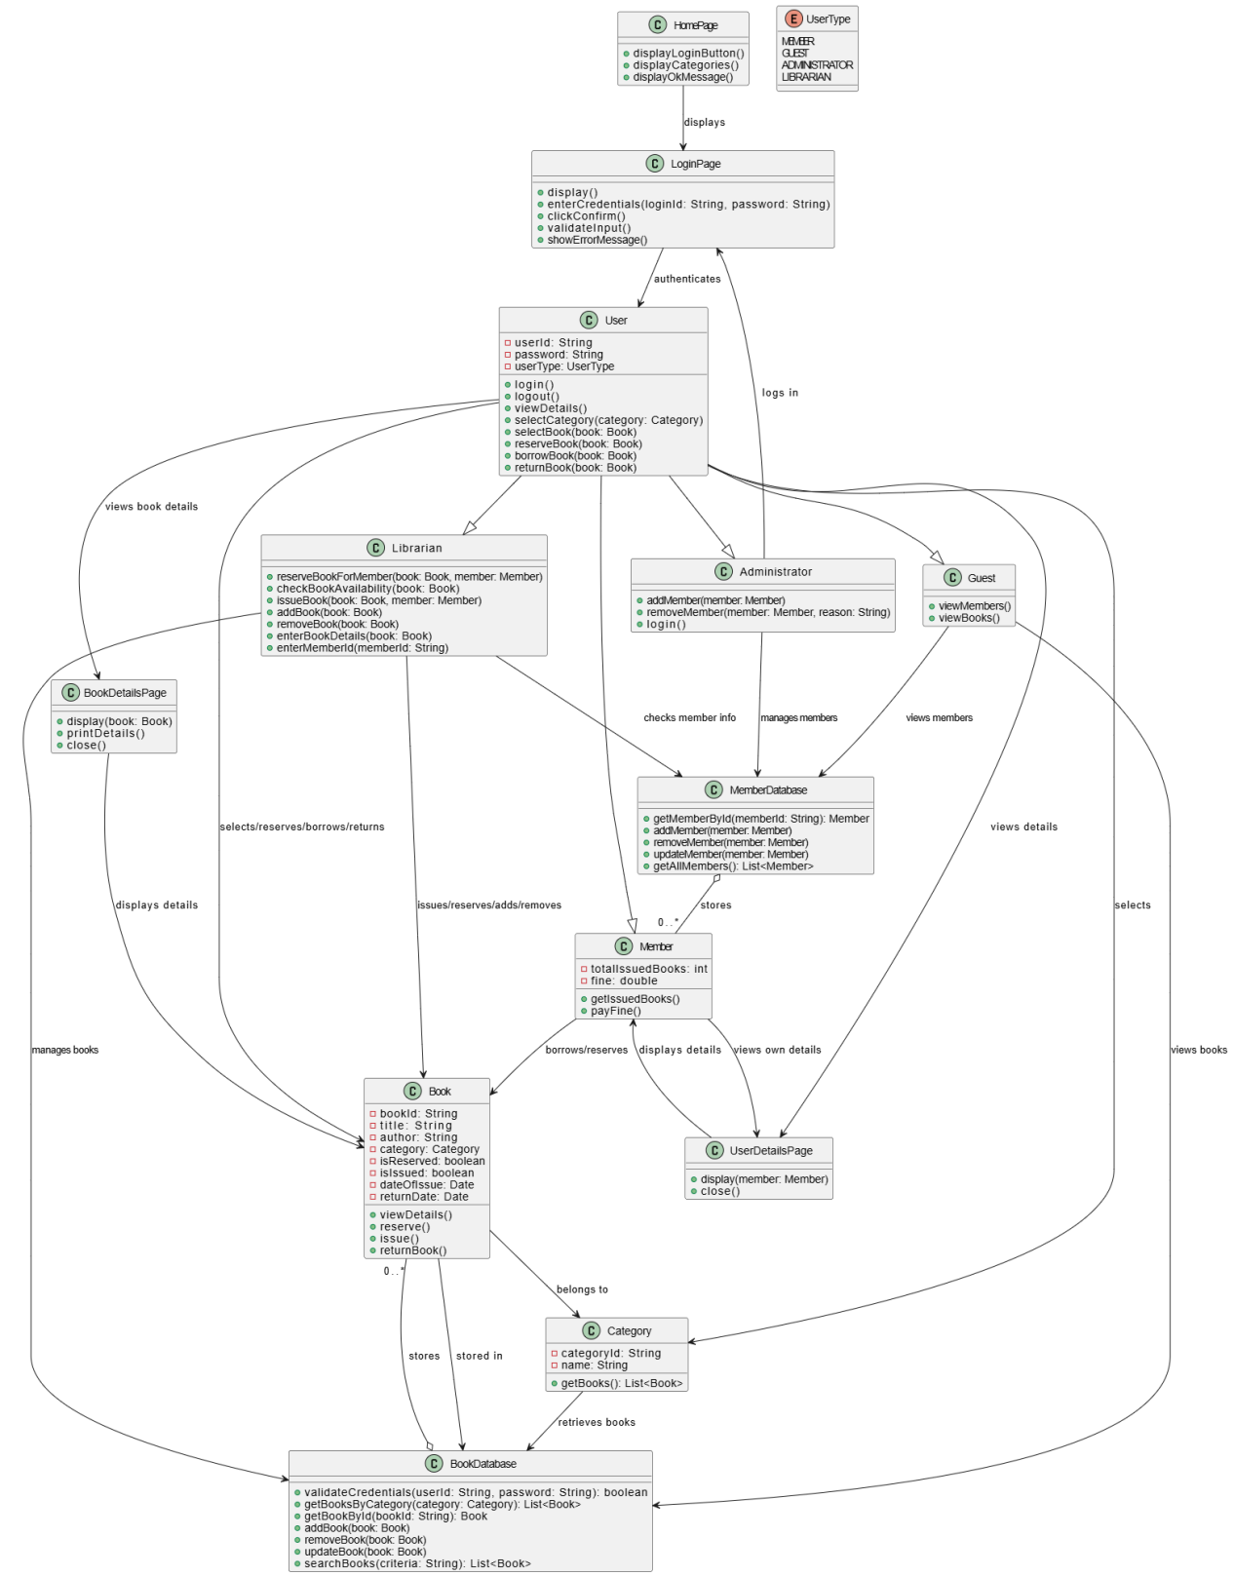

Sequence Diagram (VeriGen)

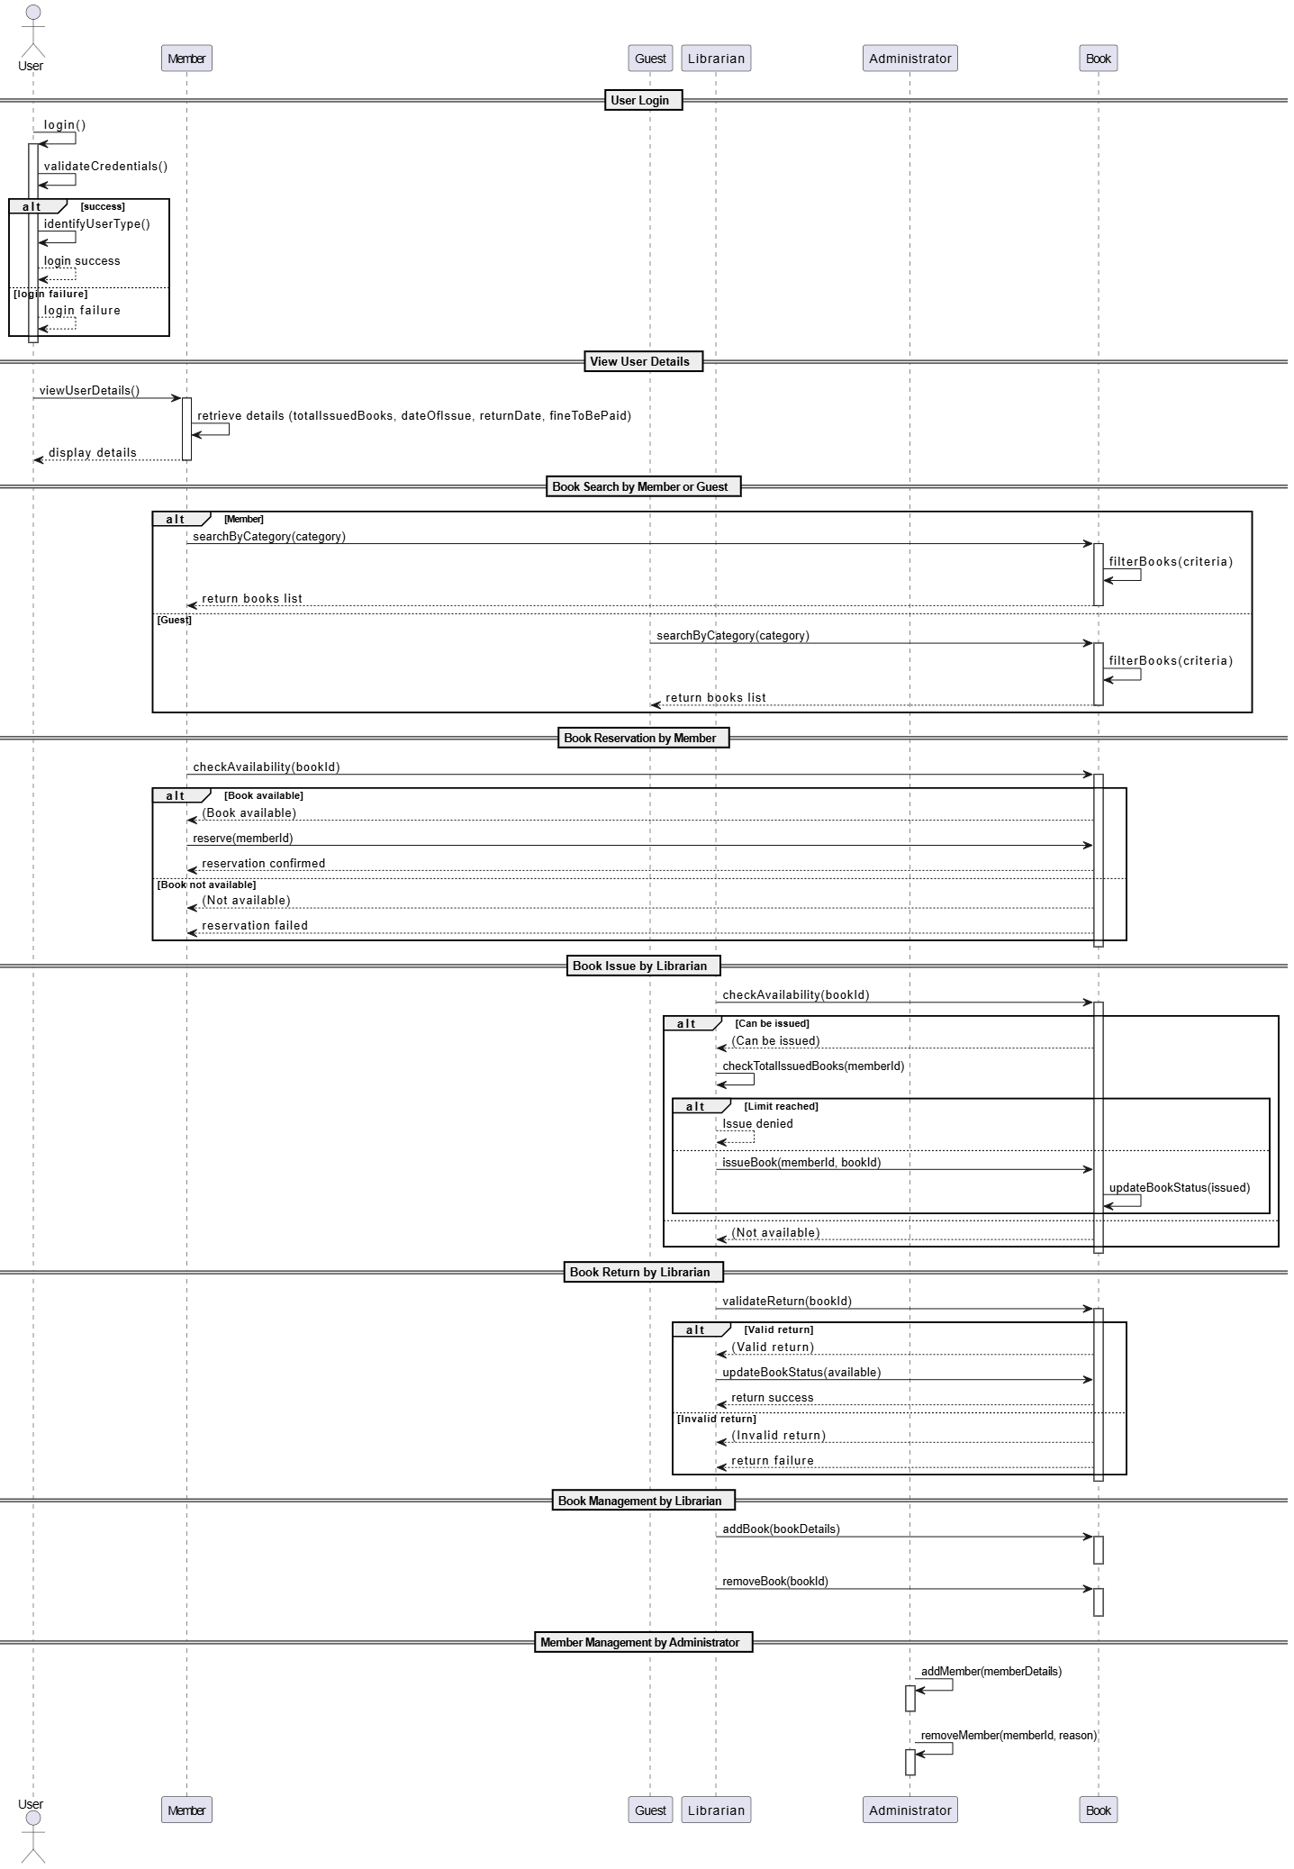

Sequence Diagram (GPT)
